Usecase diagram -   
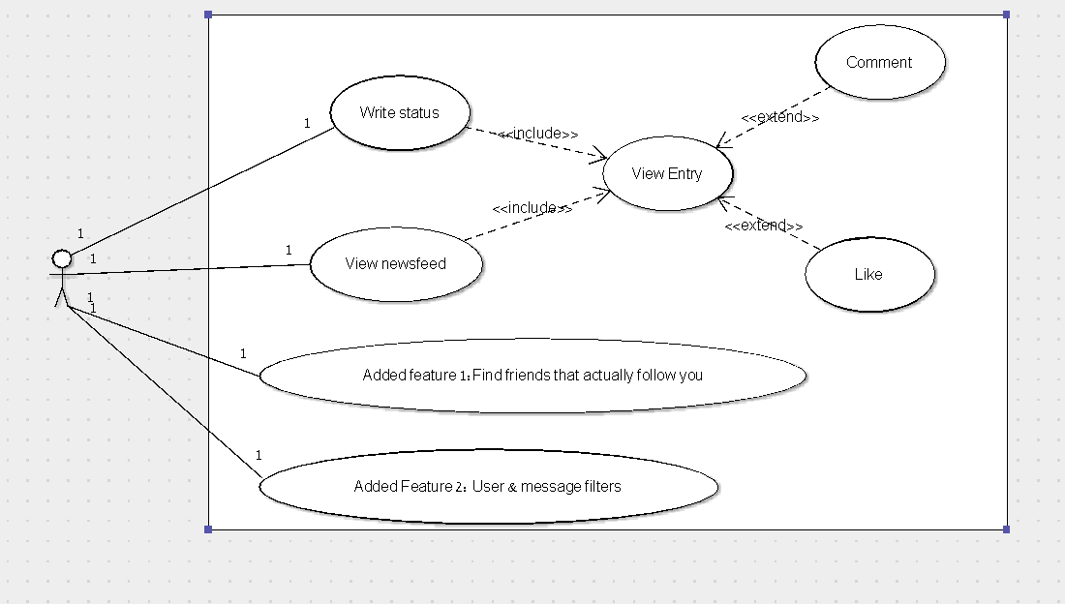  
  
Class diagram:  
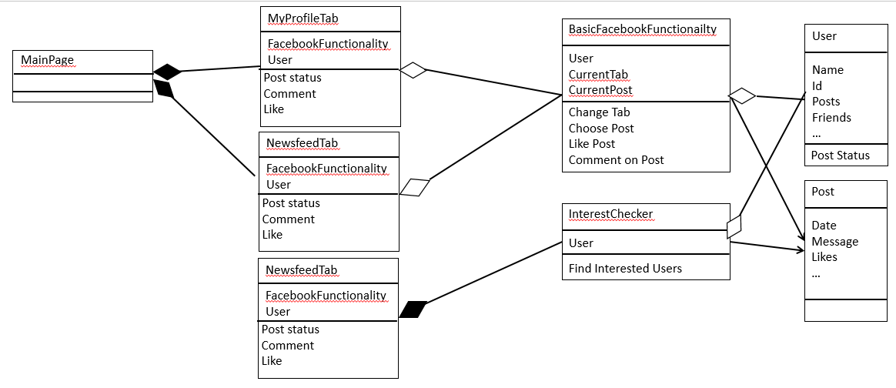  
Feature 1: Interest checker -   
This feature checks which people are actively seeing your posts, statuses, etc., by checking who commented or liked one of your posts. It's operated through the Interest Check tab, where you can define the earliest date of posts to check from, and the amount of items of each type to retrieve.

Place in code: the InterestPage is the UserControl in charge of the feature, and the InterestChecker object is the object running the logic behind it.   
  
Feature 2: Filter Friends by preconfigured filter &  
 Filter Messages by preconfigured filter   
This feature filter friends by advanced preconfigured filter with parameters of age, gender and friends list belonging. You can also filter messages that contains a friend that the advanced filter "approved".   
you add the filter in the filters tab. The friends will be filtered in friends tab and messages in messages tab.  
  
Place in code: the FirendsFiltersPAge, FriendsPage and InboxPage in the GUI (tabs friends, Messages, Friends Filters), the logic is handled by FacebookApplicationManager .

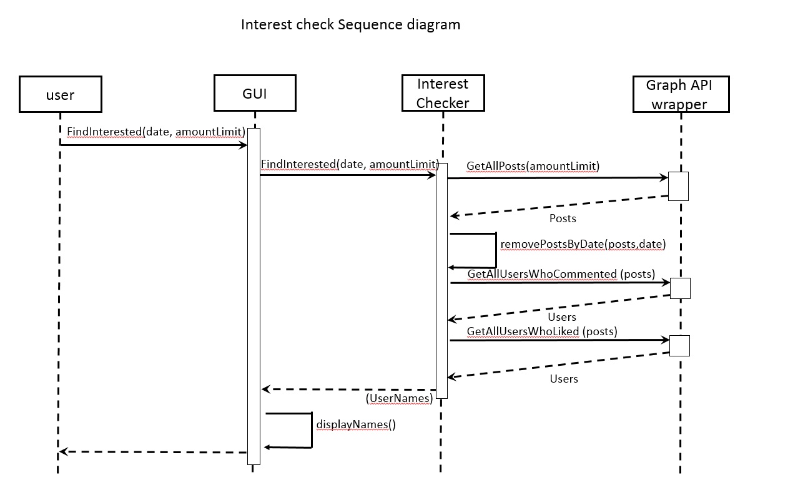

Message filter Sequence diagram

